Project 2 – Building GV-NAP File Sharing System

Overview
GVNAP is a client server network application that is designed to provide similar services as Napster on the internet. In particular file sharing in a peer to peer manner. The basic architecture is that of a centralized server which stores a list of all users currently registered with that particular centralized server and a list of all files currently available for download from remote servers. The remote clients and servers basically operate as standard FTP clients and servers and operate per RFC 959.

Design
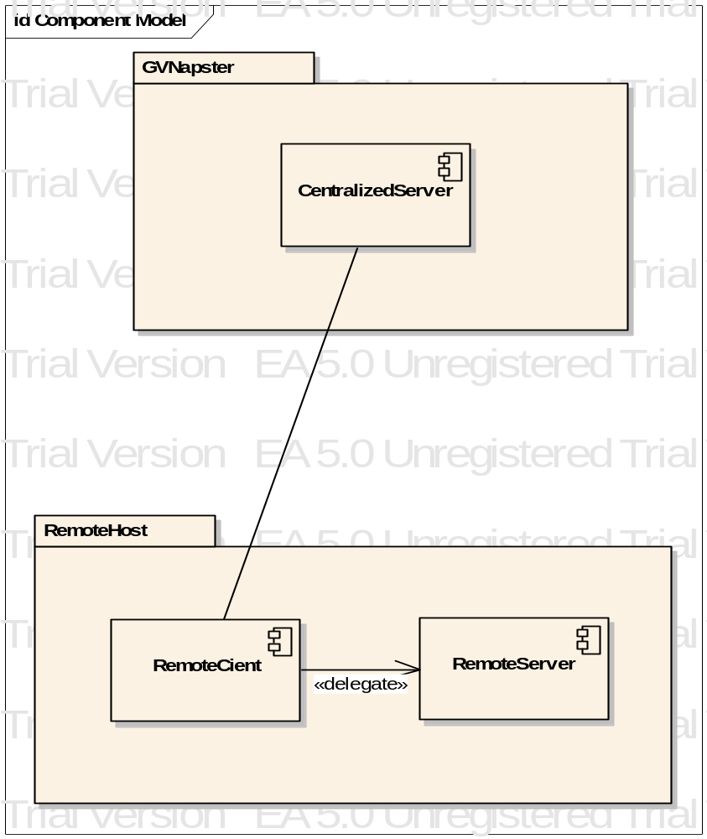

Features
GVNAP features a GUI interface implemented with the javax.swing library.
- Menu system
- Permanent storage of shared file lists
- Dynamic sorting of shared file lists and search results (Note: algorithm by others)
- Informational status messages from responses from server.
- ObjectOutputStreams/ObjectInputStreams simplify sending and receiving objects.

Problems
Overall there were not real big problems with this project, other than scope. This project is much too big for a couple week project.
My design of GVNAP Centralized server was a good design and worked well with very little changes after the first implementation. The client went well also, but was somewhat more challenging as I need to recall much of the swing library. The biggest issue I has was utilizing the FTPClient/Server from project 1. I am not totally happy with the design, but I had to make use of it as I did not have time to reimplement it.

Summary
In all this has been a good project, abet a long project. I am confident that I can implement any network application using TCP and socket.

